EXPT NO:5 | DASHBOARD DESIGNING
DATE: 24.01.2026 | DASHBOARD DESIGNING

PRE-LAB QUESTIONS
- How do dashboards support strategic decision-making?

Dashboards support strategic decision-making by presenting key information in a visual and summarized form. They help decision-makers quickly identify trends, patterns, and anomalies in data, enabling faster and more informed decisions. By consolidating data from multiple sources, dashboards provide a holistic view of system performance and progress toward organizational goals.

- What role do dashboards play in AI monitoring systems?

In AI monitoring systems, dashboards act as the primary interface for observing model outputs, system behavior, and real-time metrics. They help track AI performance, detect anomalies, and evaluate predictions, ensuring transparency and reliability in AI-driven processes.

- Why is interactivity essential in modern dashboards?

Interactivity allows users to explore data dynamically through filters, drill-downs, and selections. It enables users to focus on specific insights relevant to their needs, making dashboards more flexible, user-friendly, and effective for detailed analysis.

- What cognitive overload issues exist in dashboards?

Cognitive overload occurs when dashboards present too much information at once, such as excessive charts, colors, or metrics. This can confuse users, reduce comprehension, and slow decision-making. Poor layout and lack of prioritization also contribute to overload.

- How are KPIs derived from raw data?

KPIs are derived by processing raw data through data cleaning, aggregation, and analysis. Relevant metrics are identified based on organizational goals, and formulas or calculations are applied to convert raw values into meaningful performance indicators.

IN-LAB EXERCISE:
OBJECTIVE: To design an interactive analytical dashboard for monitoring key metrics.
SCENARIO: An AI-based smart campus system requires a dashboard to monitor attendance, academic performance, and resource utilization in real time.
IN-LAB TASKS (Using PowerBI)
• Design KPI cards for attendance and performance
• Implement filters by department and semester
• Link multiple views for drill-down analysis

Procedure:

Step 1: Open Power BI Desktop and close the startup screen if it appears.
Step 2: Click Home → Get Data → Text/CSV, select the file 5.student_performance.csv, and click Open.
Step 3: In the preview window, click Transform Data to open the Power Query Editor.
Step 4: Go to Add Column → Custom Column, name it Total_Score, and enter the formula [Internal_Test1] + [Internal_Test2] + [Assignment_Marks].
Step 5: Click OK and select Home → Close & Apply to load the transformed data.
Step 6: Insert a Text Box and set the dashboard title as “Smart Campus Monitoring Dashboard”.
Step 7: Insert a Card visual, drag Attendance_Percentage, change aggregation to Average, and rename it as “Avg Attendance %”.
Step 8: Insert another Card visual, drag Total_Score, and set aggregation to Average.
Step 9: Insert a Slicer visual, drag Department, and format it using Tile style.
Step 10: Insert another Slicer visual, drag Semester, and choose a suitable layout.
Step 11: Insert a Clustered Column Chart and drag Total_Score to Y-axis with Average aggregation.
Step 12: Drag Department, Semester, and Subject sequentially to the X-axis to create a drill-down hierarchy.
Step 13: Enable Drill-Down mode and navigate from Department to Semester to Subject using chart interactions.
Step 14: Insert a Pie Chart, drag Final_Grade to Legend, and Student_ID to Values with Count aggregation.
Step 15: Click on any grade segment to observe automatic updates across KPI cards and charts.
Step 16: Arrange all visuals on a single page and verify filters, drill-down, and interactivity.

Output:

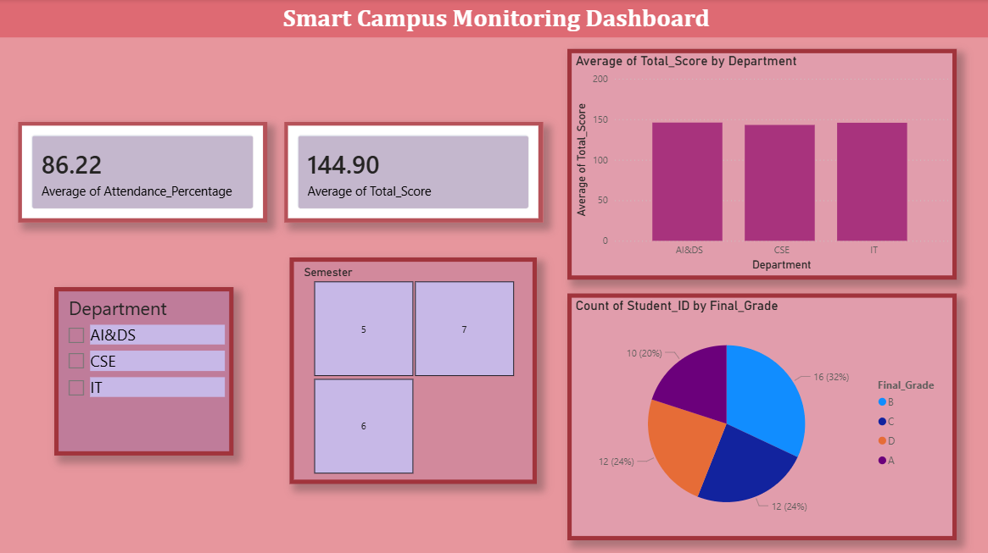

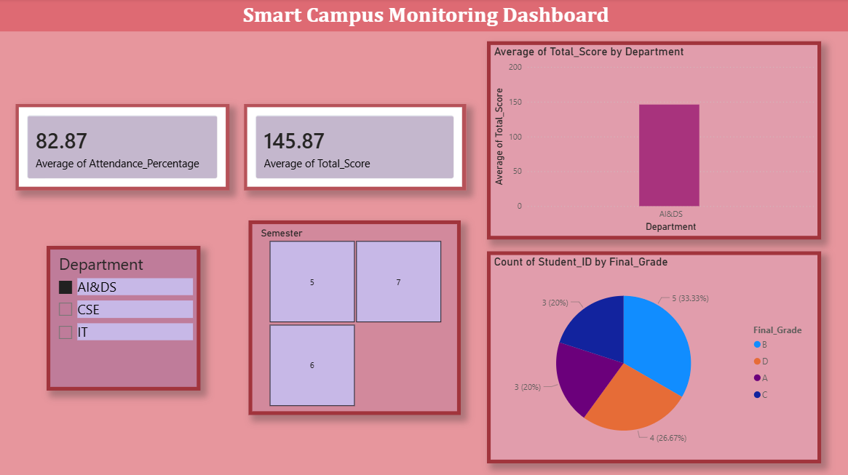

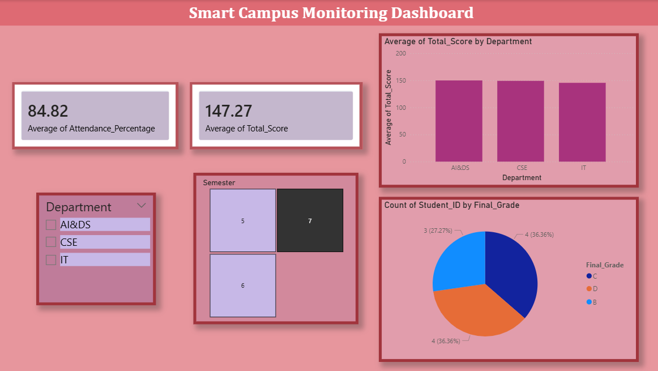

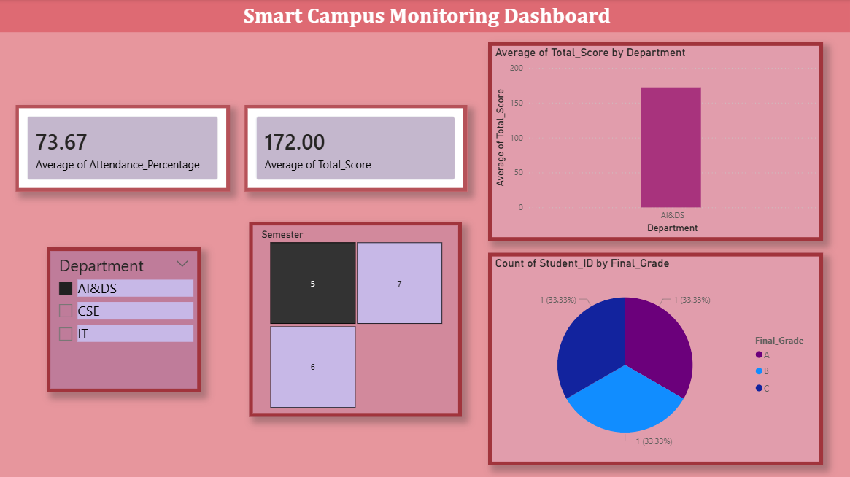

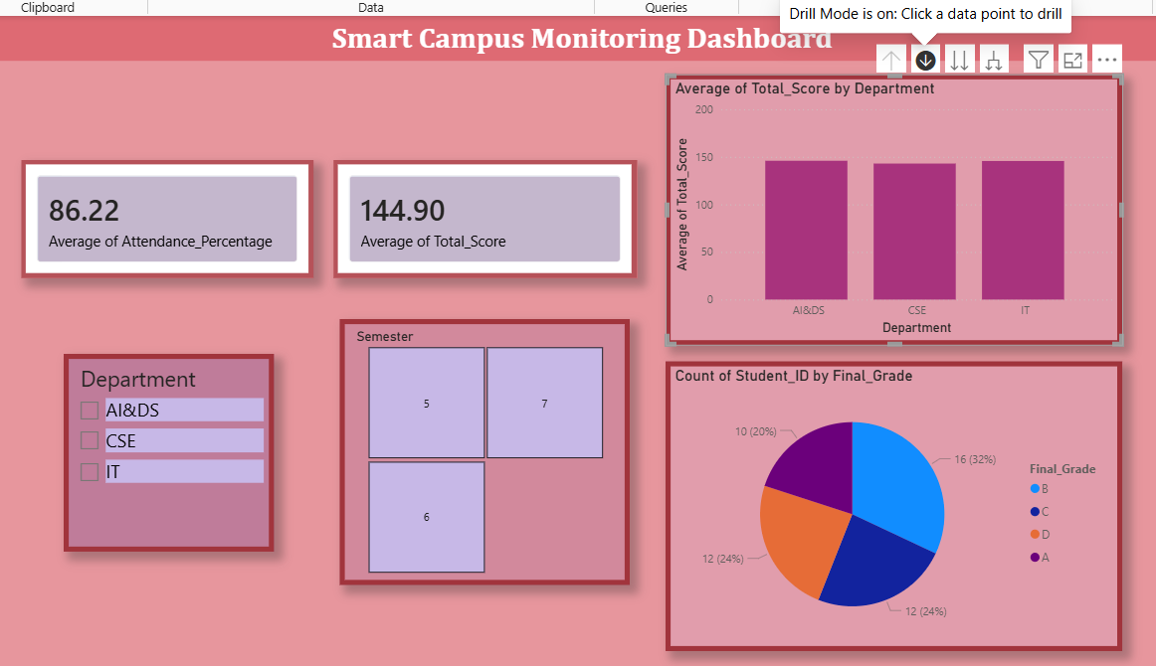

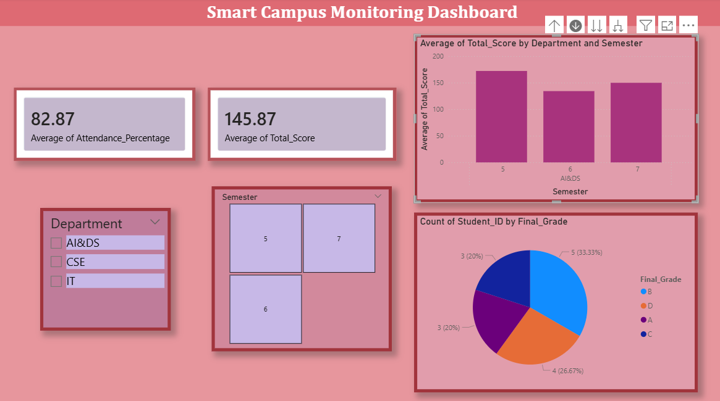

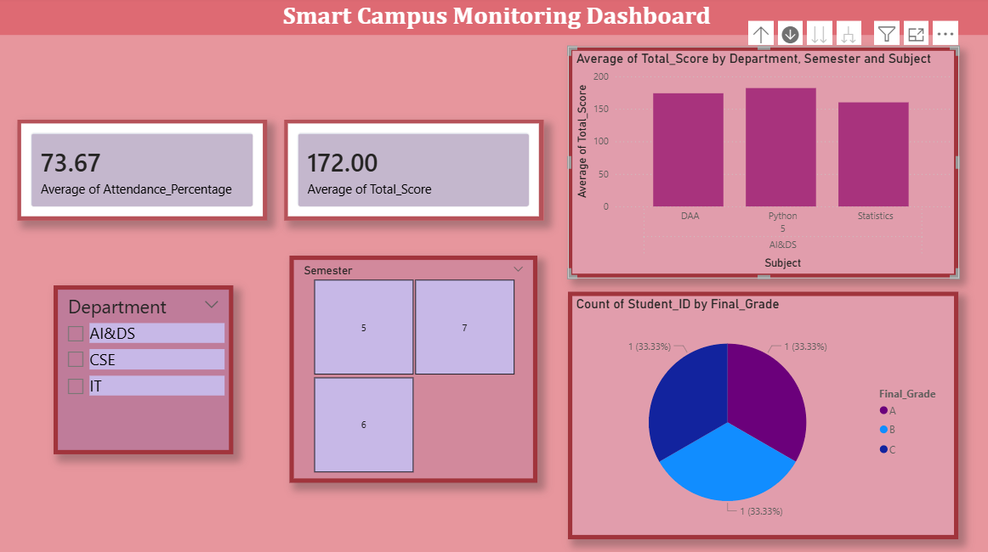

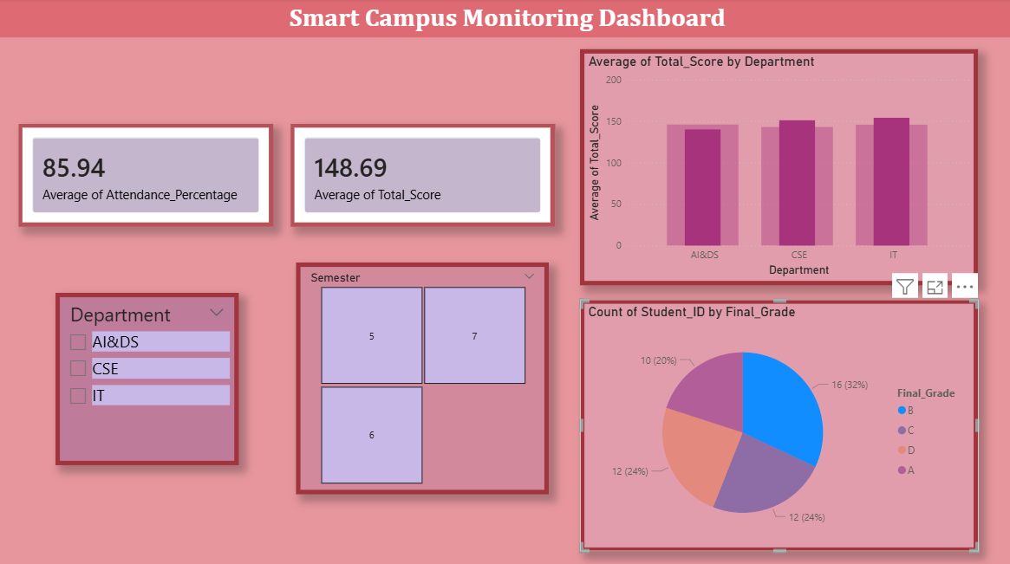

POST-LAB QUESTIONS
- How does interactivity improve analytical depth?

Interactivity enables users to filter data by department and semester for focused analysis. It allows deeper exploration of attendance, scores, and grades. Users can identify trends, patterns, and performance variations easily. This improves data-driven academic decision-making.

- Which KPIs are critical for academic monitoring?

Key KPIs include average attendance percentage, average total score, department-wise performance, and grade distribution. These indicators help track student engagement and academic progress. They support early identification of performance issues. Institutions can improve outcomes using these metrics.

- What design principles prevent information overload?

The dashboard follows clear visual hierarchy and uses summary KPI cards. Limited colors and well-organized charts improve readability. Related data is grouped logically to reduce clutter. This ensures users quickly understand key insights.

- How can dashboards be integrated with AI alerts?

AI algorithms can monitor dashboard data in real time. Alerts can be generated for low attendance or declining scores. These notifications help faculty take timely corrective actions. This enhances proactive academic management.

- How do dashboards enhance transparency in institutions?

Dashboards provide centralized and visual access to academic data. Stakeholders can easily view performance metrics and trends. This improves accountability and trust. Data-driven transparency supports informed institutional decisions.

LEARNING OUTCOME: Students understand dashboard design for AI-driven environments.

ASSESSMENT
Description | Max Marks | Marks Awarded
Pre Lab Exercise | 5
In Lab Exercise | 10
Post Lab Exercise | 5
Viva | 10
Total | 30
Faculty Signature

